Boulogne-Billancourt - June 1, 2021

**2021 Movin’On: Michelin presents two innovations to accelerate the development of sustainable mobility**

* **The WISAMO project, an innovative solution contributing to the decarbonization of maritime shipping**
* **A high-performance racing tire containing 46% sustainable materials**
* **Two further illustrations of the Group’s “all-sustainable” strategy**

At the 2021 Movin’On global sustainable mobility summit, Michelin has transformed ambition into action by presenting two innovations that address some of the major challenges impacting the future of mobility. Designed to make transportation more efficient while conserving resources, Michelin's latest solutions represent core enablers in the efforts being pursued by Movin’On and its ecosystem to foster mobility that is gentler on the planet.

**The WISAMO project, an innovative solution to help decarbonize maritime shipping.**

|  |  |
| --- | --- |
|  | The Wing Sail Mobility (WISAMO) project is an automated, telescopic, inflatable wing sail system that can be fitted on both merchant ships and pleasure craft. The system is the product of a collaborative venture between Michelin Research & Development and two Swiss inventors who share the Group’s “all-sustainable” vision. |

The inflatable wing sail harnesses the wind, a free, universal and inexhaustible source of propulsion. Its revolutionary design enables a ship to reduce its fuel consumption and thereby have a positive impact on the environment by lowering CO2 emissions.

Designed and developed by the WISAMO project team, the system is installable on most merchant ships and pleasure craft. Especially suitable for ro-ro ships, bulk carriers and oil and gas tankers, it can be fitted as original equipment on newbuilds or retrofitted on in-service vessels.

The wing’s range of use is one of the market’s broadest, with proven effectiveness on many points of sail, and especially when close-hauled (windward). It can be used on every maritime shipping route. The telescopic mast is retractable, making it easy for a ship to enter harbors and pass under bridges. In all, the system can improve a ship’s fuel efficiency by up to 20%*.

A collaboration with Michel Desjoyaux, a world-renowned skipper and ambassador of the project, enables Michelin's research teams to perfect its development. His input and technical knowledge of this seasoned sailor will enable it to be tested in actual maritime shipping conditions. As Desjoyeaux points out, “the advantage of wind propulsion is that wind energy is clean, free, universal and totally non-controversial. It offers a very promising avenue to improving the environmental impact of merchant ships.”

The WISAMO system will first be fitted on a merchant ship in 2022, when Michelin expects it to go into production following completion of the trial phase.

The WISAMO project is Michelin’s contribution to enabling greener, softer maritime mobility in advance of future regulations. Michelin is also taking action to reduce the environmental impact of its supply chain. In addition to this commitment, and in line with its strategic plan, the Group is basing a portion of its growth on the development of new businesses.

**A track-proven tire with 46% sustainable content**

At the 2021 Movin’On Summit, Michelin is also set to unveil a racing tire containing 46% sustainable materials, fitted to the GreenGT Mission H24 hydrogen-powered prototype developed for endurance racing.

With its totally new innovation engineered for motorsports, Michelin has found what many observers thought was impossible: a way to make a tire with high sustainable content that still delivers superior on-track performance.

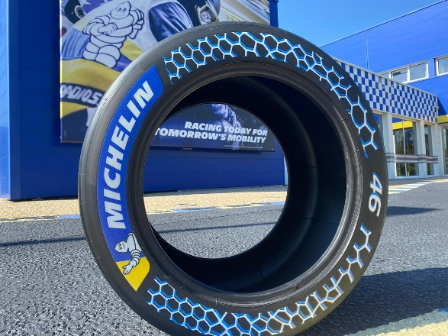

This very high percentage was achieved by increasing the tire’s natural rubber content and using recycled carbon black recovered from end-of-life tires.

Other bio-sourced or recycled sustainable materials used in the tire include such everyday items as orange and lemon rind, sunflower oil, pine resin and recycled steel from aluminum cans.

As a real-world technological laboratory, motorsports enable Michelin to develop and test new high-tech solutions in extreme usage conditions. With this innovative partnership, Michelin is showcasing its ability to incorporate an ever-higher proportion of sustainable materials into its products without compromising on their performance.

This year, Michelin announced its commitment to using 100% sustainable materials in all its tires by 2050. This commitment will reach an initial milestone in 2030, with a Group-wide target of having 40% sustainable materials in its tires.

Alongside its commitment to integrating sustainable materials into its tires, Michelin also uses eco-design processes to attenuate its tires’ environmental impact at every stage in their lifecycle, from raw materials sourcing and production to road use and recycling.

“*We share a core value with Movin’On and its partners, namely the deep belief that mobility, and movement in the broadest sense of the term, are inherent to life and a source of progress*,” says Michelin Managing Chairman Florent Menegaux. *“The two innovative solutions we are presenting at this year’s global sustainable mobility summit offer tangible, real-world proof of our determination to make mobility increasingly sustainable.”*

Michelin, the leading mobility company, is dedicated to enhancing its clients’ mobility, sustainably; designing and distributing the most suitable tires, services and solutions for its clients’ needs; providing digital services, maps and guides to help enrich trips and travels and make them unique experiences; and developing high-technology materials that serve a variety of industries. Headquartered in Clermont-Ferrand, France, Michelin is present in 170 countries, has 123,600 employees and operates 71 tire production facilities which together produced around 170 million tires in 2020. ([www.michelin.com](http://www.michelin.com))

MICHELIN GROUP MEDIA RELATIONS

**+33 (0) 1 45 66 22 22**

7 days a week

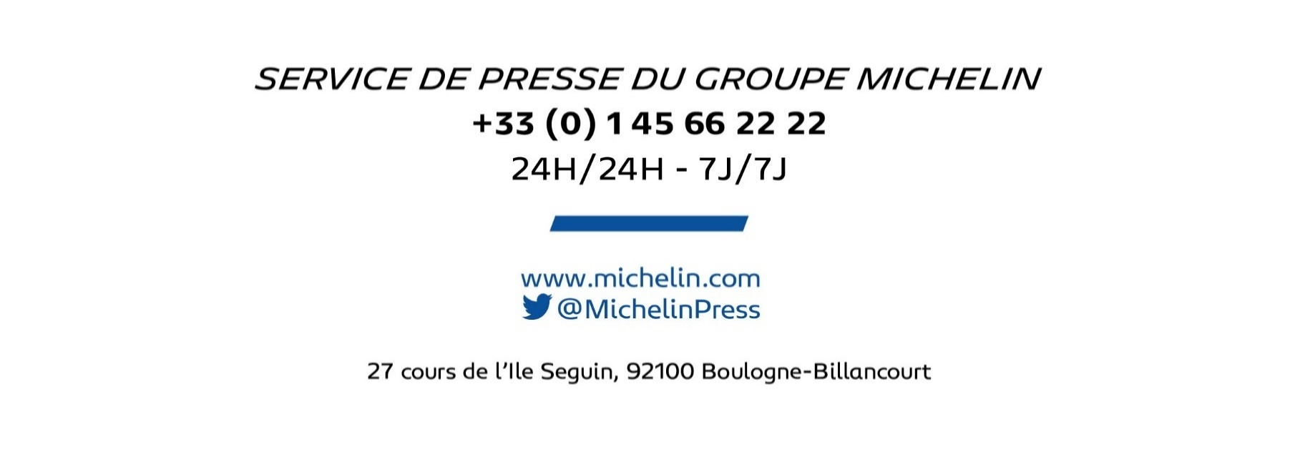

|  |
| --- |
| www.michelin.com |
| @MichelinPress |

27 cours de l’Ile Seguin, 92100 Boulogne-Billancourt